

SPRINT 3

TEAM 11:
DONNA OMABOE, LESLIE TETTEY, LAWRENCIA KYEI,
SHEPHERD ADIKO

WEB TECHNOLOGIES
CS341_B
KWADWO OSAFO-MAAFO

NOVEMBER 21ST, 2025

Final System Architecture
Our digital diary application follows a 3-tier architecture pattern.

Tier 1: Presentation Layer (Client-Side)
- Technologies: HTML5, CSS, JavaScript.
- Key Components: User Interface components (Login, Dashboard, Entry Forms), client-side form validation, chart visualization for mood analytics, and a file upload interface for media.
- Responsibilities: Display data, capture user input, make API calls, and render charts.

Tier 2: Application Layer (Server-Side)
- Technologies: PHP
- Key Functions:
  - Authentication: user registration, login, session management.
  - Entry Management: CRUD operations for diary entries.
  - Media Processing: file upload handling, validation, storage.
  - Mood Analytics: data aggregation and statistical calculations.
  - Quote: random quote generation and daily quote tracking.

Tier 3: Data Layer (Database & Storage)
- Technologies: MySQL Database
- Contents/Structure: Stores users, entries, moods, quotes, and sessions in a MySQL database. Utilizes 7 normalized tables with proper relationships, indexed columns, and foreign key constraints.

System Flow & Page Interactions
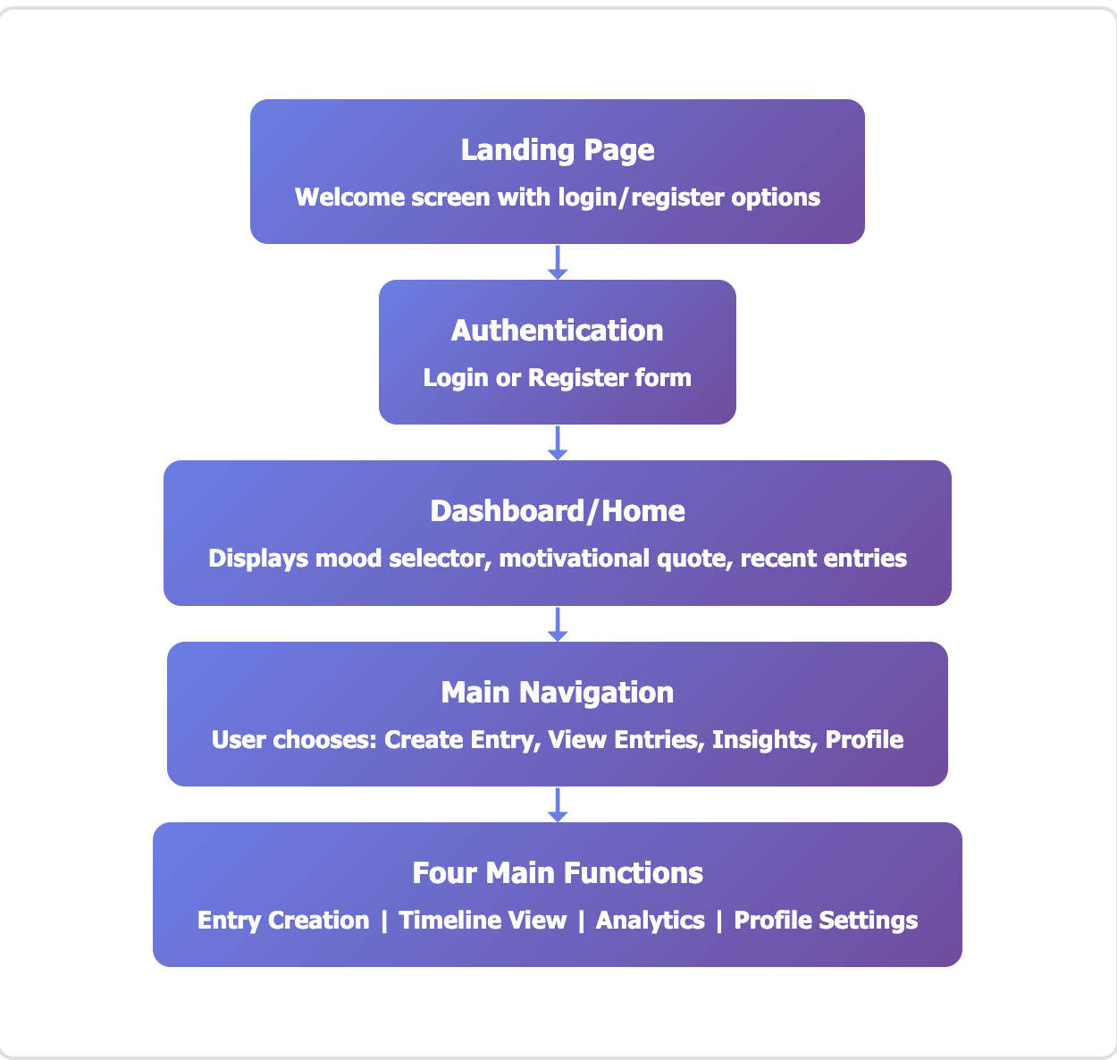
- Register Page (register.html): Uses client-side validation and redirects to the Login Page on success.
- Login Page (login.html): Submits a POST request to /api/auth/login.
- Dashboard (dashboard.html): Displays a motivational quote, a quick entry form, and the last 5 recent entries.
- Entry Creation Page (create-entry.html): Includes a rich text editor, mood selector (10 moods), an editable date/time picker, media upload for images (JPG, PNG) and media (MP3, MP4).
- Timeline/Entries Page (entries.html): Displays entries and offers filtering by date range, mood, and keyword search.
- Edit Entry Page (edit-entry.html): Loads existing entry data and updates the entry to the same endpoint.
- Insights/Analytics Page (insights.html): Fetches data and visualizes mood distribution and trends using.
- Profile Page (profile.html): Contains options to view/edit profile information, change the password, view account statistics, and Logout.

Remaining functionality for Final Delivery
Completed features
Database schema: Complete MySQL database with 7 tables, relationships, indexes, and sample data
System architecture: 3-tier architecture design with clear component interactions and API structure
ERD Documentation: Comprehensive Entity Relationship Diagram with all entities, attributes, and relationships

Features in progress
User authentication backend: registration, login and password hashing
Authentication frontend: login and register pages as well as form validation
Entry CRUD API: backend endpoints for creating, reading, updating, deleting entries
Dashboard Interface: main dashboard for recent entries display
Entry creation page: full entry form with tech selector, mood editor and media upload
Media upload handling: backend file upload processing, validation and storage
Timeline entries page: display all entries with filtering, sorting and search
Entry detail and edit: viewing full entry and edit functionality
Mood analytics backend: API endpoints for mood statistics and trends data
Insights page: chart visualization for mood trends
Quote system: random quote API, daily quote tracking and display on dashboard
Profile management: viewing and editing

